JVM Performance Optimisation Training Summary (Sept 2024 by [yCrash](https://ycrash.io/java-performance-training))

# Performance KPI (Key Performance Index)

1 – Throughput

* Percentage of work-related tasks done. E.g. in 24 hours, a system spends a total of 5 minutes for GC. ∴throughput = (100 - ( 5 / ( 24 x 60)) x 100)% = 99.652%.

2 – Latency

* Amount of time taken for GC: maximum, average, distribution.

3 – Footprint

* Amount of CPU time taken for GC.

[GCEasy](https://gceasy.io/) can be used to display the information based on GC log as shown below. See GC log section for more details on GC log).

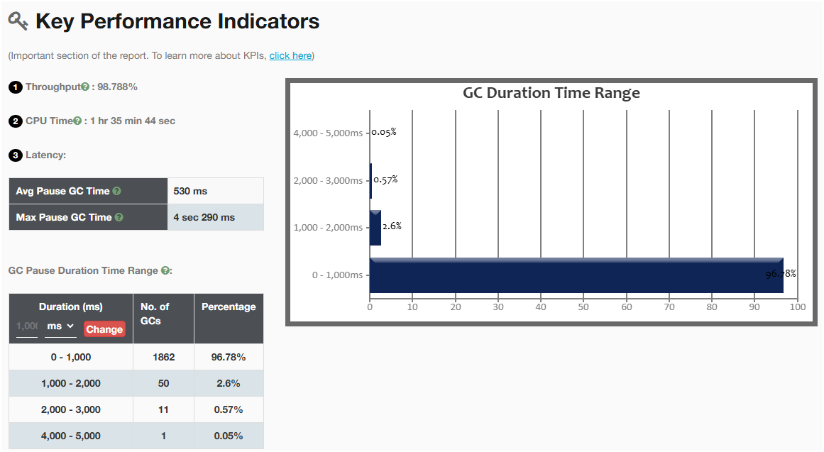

# Performance Problems

## CPU Spike

### Why

* Blocked thread(s)

### How to Solve

1. Using *top* tool, confirm that there is CPU spike. Command: *# top -H -p <pid>*

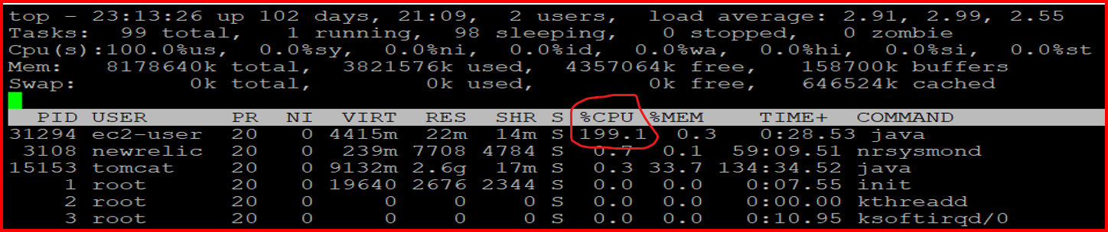

1. Identify which threads caused the spike.

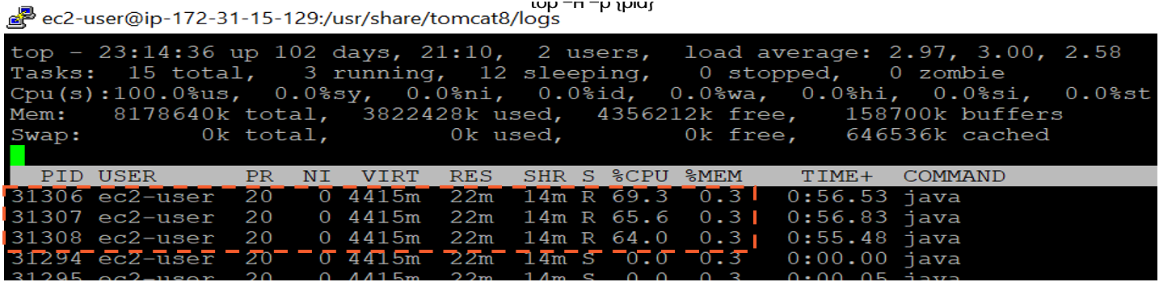

1. Collect thread dump and lookup these threads: JMC, jcmd, JVisualVM
2. Identify and resolve lines of code that causes the blocking from stack trace of the identified threads. This can be also done in thread analysis tools: JVisualVM, FastThread.

## OutOfMemoryError

### Why

Not enough certain type of memory specified in the type of the OOME - specified in *java.lang.OutOfMemoryError: <type>*, where *type* can be:

* Java heap space
* GC overhead limit exceeded
* Requested array size exceed VM limit
* Permgen space
* Metaspace
* Unable to create new native thread
* Kill process or sacrifice child
* Reason stack_trace_with_native method

Memory leak can be the main cause.

### How to Solve

1. Capture heap dumps: jmap, jcmd
2. Analyse to look for root cause: HeapHero, JVisualVM

See Heap Dump section for more details.

## StackOverflowError

### Why

Not enough stack size configured.

### How to Solve

Adjust stack size using JVM argument -Xss.

# GC Patterns

## Healthy GC (sawtooth)

## Acute Memory Leak (uptrend)

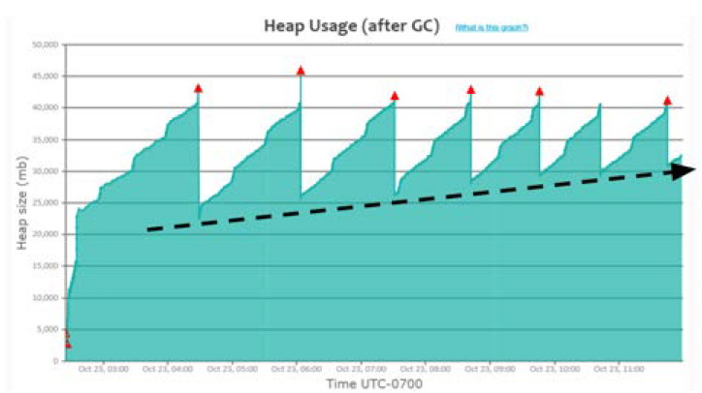

## Heavy Caching

## Metaspace memory problem

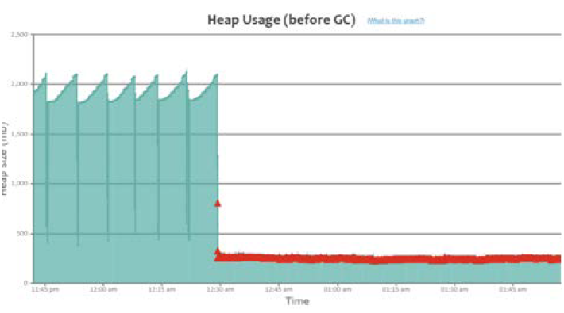

# Useful JVM Arguments for Optimisation

## Heap

Use one of the followings to specify your application heap size:

|  |  |
| --- | --- |
| **JVM Arguments** | **Remarks** |
| -Xmx | Supported in all versions of JDK.  Example:  # java -Xmx512m -XshowSettings:vm -version |
| -XX:MaxRAMFraction  -XX:MinRAMFraction | Only available in JDK8u131-190.  Recommended for containers. Should be used in conjunction with:  -XX:+UnlockExperimentalVMOptions  -XX:+UseCGroupMemoryLimitForHeap  Example:  # docker run -m 1GB openjdk:8u131 java  -XX:+UnlockExperimentalVMOptions  -XX:+UseCGroupMemoryLimitForHeap  -XX:MaxRAMFraction=2  -XshowSettings:vm -version |
| -XX:MaxRAMPercentage  -XX:MinRAMPercentage | Available in JDK8u191 and above.  Recommended for app deployed in containers.  Example:  # docker run -m 1GB openjdk:10 java  -XX:MaxRAMPercentage=50  -XshowSettings:vm -version |

## Metaspace

* Region where class definitions, method definitions, and other JVM metadata are stored.

|  |  |
| --- | --- |
| **JVM Arguments** | **Remarks** |
| -Xx:MaxMetaspaceSize | Example:  -XX:MaxMetaspaceSize=256m |

## Stack:

|  |  |
| --- | --- |
| **JVM Arguments** | **Remarks** |
| -Xss | Specifies stack size. Adjust with knowledge of total number of thread as value is per thread.  Example:  -Xss256k |

## GC selection

Use one of the followings:

|  |  |
| --- | --- |
| **JVM Arguments** | **Remarks** |
| -XX:+UseSerialGC | To use Serial GC algorithm. |
| -XX:+UseParallelGC | To use Parallel GC algorithm. |
| -XX:+UseConcMarkSweepGC | To use CMS GC algorithm. |
| -XX:+ UseG1GC | To use G1GC GC algorithm. |
| -XX:+ UseShenandoahGC | To use Shenandoah GC algorithm. |
| -XX:+ UseZGC | To use Z GC algorithm.  Starting JDK23:  To use Z GC Generational, add:  -XX:+ZGenerational  Or, to use non-generational, add:  -XX:-ZGenerational |

### When to Use What

Guide taken from [here](https://www.youtube.com/watch?v=2AZ0KKeXJSo&list=PLYe9-n3XGabh2p95ptzEoIbHuM7jdRO5S&index=5&ab_channel=DefogTech).

With G1GC, you can specify the soft-target for maximum GC pause time using JVM args:

* ***-XX:MaxGCPauseMillis***
* ***-XX:GCPauseIntervalMillis***

## Timeouts

Use any of the followings if needed:

|  |  |
| --- | --- |
| **JVM Arguments** | **Remarks** |
| ‑Dsun.net.client.defaultConnectTimeout | Timeout to connect to host.  Example:  ‑Dsun.net.client.defaultConnectTimeout=2000 |
| -Dsun.net.client.defaultReadTimeout | Timeout when reading from input stream.  Example:  -Dsun.net.client.defaultReadTimeout=2000 |

# Useful JVM Arguments for Troubleshooting

## GC log:

* Analyse GC log for period of 24 hours during weekdays for high and low traffic monitoring.
* Can be used to troubleshoot GC-related problems: long GC pauses, irresponsive application, low throughput, memory leak indication GC pattern

|  |  |
| --- | --- |
| **JVM Arguments** | **Remarks** |
| -verbose:gc  -Xloggc:<log_file_path>  -XX:+PrintGCDetails  -XX:+PrintGCDateStamps | For Java 7 and below  Example:  *java -verbose:gc*  *-Xloggc:/var/log/myapp/gc.log*  *-XX:+PrintGCDetails*  *-XX:+PrintGCDateStamps -jar myapp.jar* |
| -XX:+PrintGC  -XX:+PrintGCDetails  -XX:+PrintGCDateStamps  -Xloggc:<log_file_path>  -XX:+UseGCLogFileRotation  -XX:NumberOfGCLogFiles=<number_of_files>  -XX:GCLogFileSize=<size>[k|m|g] | For Java 8: it has additional log rotation option.  Example:  *java -XX:+PrintGC –*  *XX:+PrintGCDetails*  *-XX:+PrintGCDateStamps*  *-Xloggc:/var/log/myapp/gc.log*  *-XX:+UseGCLogFileRotation*  *-XX:NumberOfGCLogFiles=5*  *-XX:GCLogFileSize=10m -jar myapp.jar* |
| -Xlog:gc*:  file=<log_file_path>:  time,uptime,level,tags:  filecount=<number_of_files>,  filesize=<size>[k|m|g] | For Java 9 and above: it is using unified logging -Xlog  Example:  *java -Xlog:gc*:*  *file=/var/log/myapp/gc.log:*  *time,uptime,level,tags:*  *filecount=5,*  *filesize=10m -jar myapp.jar* |

### Tools

To analyse GC log, we can use:

* [GCEasy](https://gceasy.io/) by yCrash
* JDK Mission Control
* JVisualVM
* [IBM Health Centre and/or IBM GC and Memory Visualizer](https://www.ibm.com/support/pages/java-sdk-monitoring-and-post-mortem)
* [Garbage Cat](https://github.com/mgm3746/garbagecat)

With [GCEasy](https://gceasy.io/), summary and recommendations are provided like shown below:

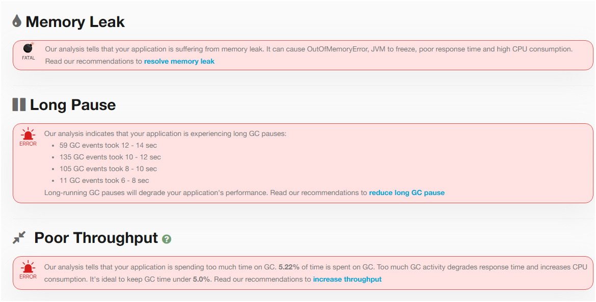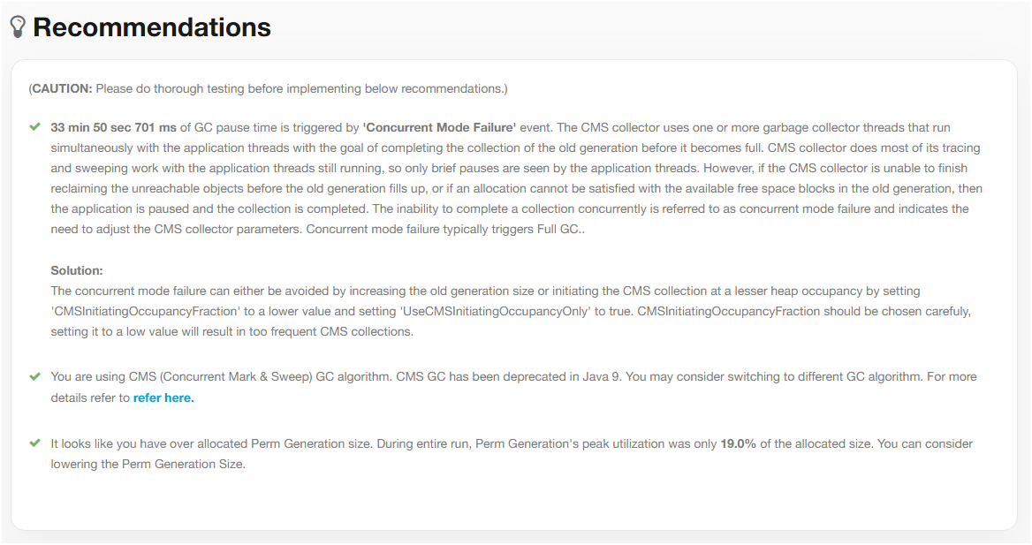

## Heap Dump

* Can be used to troubleshoot memory-related problems: slow memory leaks, GC problems, OutOfMemoryError

|  |  |
| --- | --- |
| **JVM Arguments** | **Remarks** |
| -XX:+HeapDumpOnOutOfMemoryError  -XX:HeapDumpPath=<file_path> | Example:  -XX:+HeapDumpOnOutOfMemoryError  -XX:HeapDumpPath=/opt/tmp/heapdump.hprof |
|  |  |

### Tools

1 - [HeapHero](https://heaphero.io/)

2 – jcmd.exe: available with JDK

* $ jcmd <pid> GC.heap_dump <file_path>. E.g.: $ jcmd 37320 GC.heap_dump /opt/tmp/heapdump.bin

3 – JVisualVM

## Thread Dump

* It’s a snapshot of all the threads running in a Java process.
* Can be used to troubleshoot: CPU spikes, unresponsiveness, poor response time, hung threads, high memory consumption.
* No noticeable overhead in capturing thread dumps on every 5 minutes or 2 minutes interval.

|  |  |
| --- | --- |
| **JVM Arguments** | **Remarks** |
| - |  |

### Tools

1 – jstack.exe: available with JDK

* $ jstack -l <pid> > <file_path>. E.g.: jstack -l 37320 > /opt/tmp/threadDump.txt

2 – kill-3 <pid>: available with JRE

* $ kill -3 <pid>. E.g.: $ kill -3 37320

3 – jcmd.exe: available with JDK

* $ jcmd <pid> Thread.print > <file_path>. E.g.: $ jcmd 37320 Thread.print > /opt/tmp/threadDump.txt

4 - JVisualVM

# Useful JVM Arguments as Reactive Actions

## When OutOfMemoryError

Use any of the followings:

|  |  |
| --- | --- |
| **JVM Arguments** | **Remarks** |
| -XX:+HeapDumpOnOutOfMemoryError  -XX:HeapDumpPath={heap-dump-file-path} | See Heap Dump section for more details. |
| -XX:OnOutOfMemoryError=<script_path> | Execute a script when OOME occurs.  Example:  -XX:OnOutOfMemoryError=/scripts/restart-myapp.sh |
| -XX:+CrashOnOutOfMemoryError | JVM exits when OOME occurs. Text and binary files are produced before exit. Not recommended. |
| -XX:+ExitOnOutOfMemoryError | Like CrashOnOutOfMemoryError but without text and binary files. Not recommended. |

# Recommended Practice for Optimum Performance

## Set Max Heap Size and Metaspace Size accordingly

Heap size and Metaspace size plays a role in determining the frequency of GC events for your application.

### Setup

|  |  |
| --- | --- |
| **JVM Arguments** | **Remarks** |
| -Xmx | Example:  Setting heap size to 2GB:  -Xmx2g |
| -XX:MaxMetaspaceSize | Example:  Setting Metaspace size to 256MB:  -XX:MaxMetaspaceSize=256m |

## Use ZGC for Java 11+ Application

ZGC is known for its sub-millisecond pauses, allowing latency-sensitive systems to thrive.

### Setup

|  |  |
| --- | --- |
| **JVM Arguments** | **Remarks** |
| -XX:+UseZGC |  |

## Always Enable GC Logging

GC Logging has (close to) no-impact to application performance but very useful for troubleshooting purposes. See GC log section for more details.

### Setup

|  |  |
| --- | --- |
| **JVM Arguments** | **Remarks** |
| -XX:+PrintGCDetails  -XX:+PrintGCDateStamps  -Xloggc: <file_path> | Up to JDK 8  Example:  -XX:+PrintGCDetails  -XX:+PrintGCDateStamps  -Xloggc:/opt/workspace/myAppgc.log |
| -Xlog:gc*:file=<file_path> | JDK 8 +  Example:  -Xlog:gc*:file=/opt/workspace/myAppgc.log |

## Create Heap Dump on Out of Memory Error

Heap dump is very useful in troubleshooting OutOfMemoryError in application when it happens.

### Setup

|  |  |
| --- | --- |
| **JVM Arguments** | **Remarks** |
| -XX:+HeapDumpOnOutOfMemoryError  -XX:HeapDumpPath=<file_path> | Example:  -XX:+HeapDumpOnOutOfMemoryError  -XX:HeapDumpPath=/dmp/my-heap-dump.hprof |

## Increase Stack Memory Only When Needed

Each thread will have its own stack. When not enough memory in stack, StackOverflowError is thrown.

### Setup

|  |  |
| --- | --- |
| **JVM Arguments** | **Remarks** |
| -Xss | Example:  Setting stack size to 256KB:  -Xss256k |

## Set timeout for connection

This is to avoid unresponsiveness in your application caused by remote applications and safeguard your applications high availability.

### Setup

|  |  |
| --- | --- |
| **JVM Arguments** | **Remarks** |
| -Dsun.net.client.defaultConnectTimeout  -Dsun.net.client.defaultReadTimeout | Example:  -Dsun.net.client.defaultConnectTimeout=2000  -Dsun.net.client.defaultReadTimeout=2000 |

## Set Time Zone for Your Application

This is particularly useful for sensitive business requirements in an application running in a distributed environment.

### Setup

|  |  |
| --- | --- |
| **JVM Arguments** | **Remarks** |
| -Duser.timezone | Example:  -Duser.timezone=”Asia/Kolkata” |

## Stop Wasting Memory in Your Code

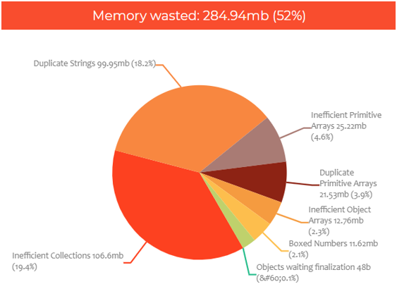

Several ways to optimise object creation and management:

Collections:

1. Lazy initialisation



1. Specify capacity:



1. Null instead of clear():



Strings:

1. Use string literals

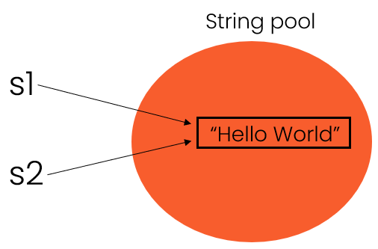

1. Use intern()

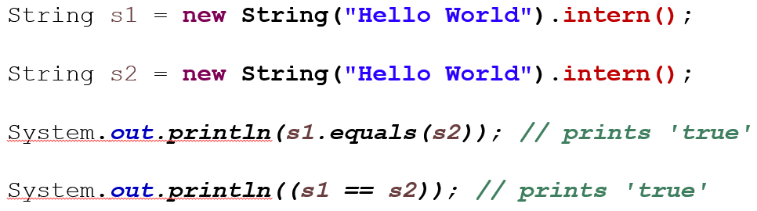

1. Alternative:
   1. Use Enum

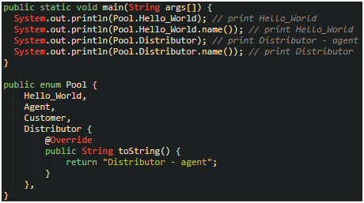

* 1. In db, consider storing data as primitive types

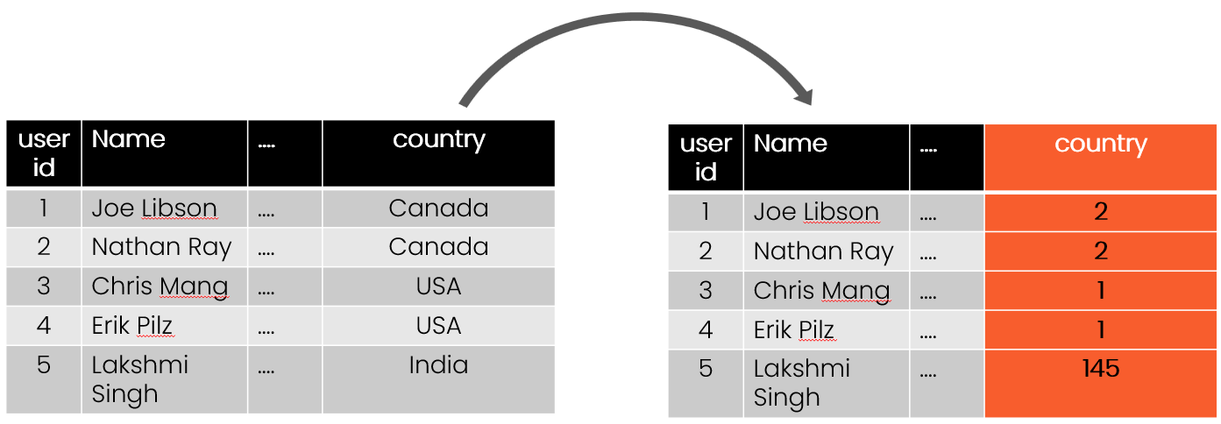

1. G1GC only: -XX:+UseDeduplication

Objects: use primitive types as much as possible and avoid boxed object as each object incurs overhead of 12bytes for header:

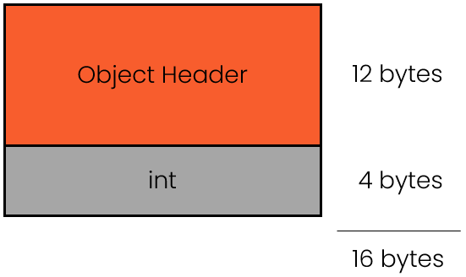

### Heap Monitoring Tools

See heap dump tools section for details.

## Use Volatile for Singleton

Inspired by a conversation with Romeu Flores. Source: [here](https://codingtechroom.com/question/singleton-pattern-with-volatile-java).

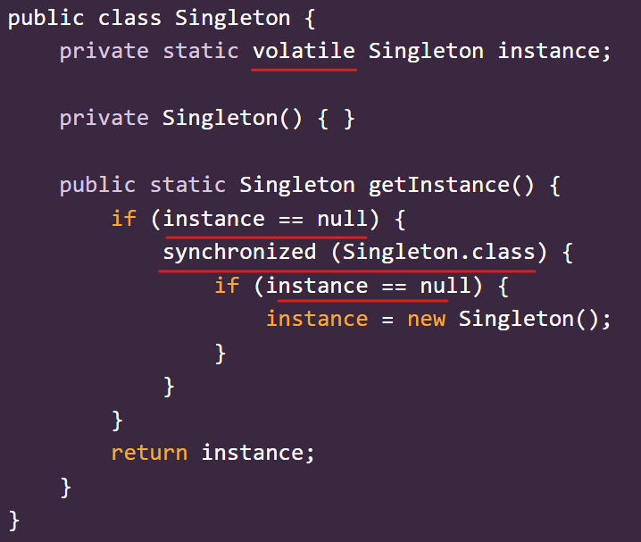

Volatile Singleton instance

The code above solves the following issues:

* Multiple threads accessing the getInstance method simultaneously can lead to multiple instances being created if proper synchronization is not used.
* The instance may not be fully initialized before another thread gets access due to issues related to caching by the CPU.

Details on the solution:

* Use the 'volatile' keyword to declare the instance variable to ensure that its value is always read from main memory, preventing caching issues.
* Implement double-checked locking in the getInstance method, which allows for lazy initialization while minimizing synchronization overhead.

Volatile keyword ensures visibility across threads.

Double-checked locking is implemented to avoid unnecessary synchronization and ensure proper instance initialization.

## Use SecureRandom for Enhanced Security

Inspired by a conversation with Romeu Flores. Source: [here](https://codingtechroom.com/question/provide-entropy-to-jvm).

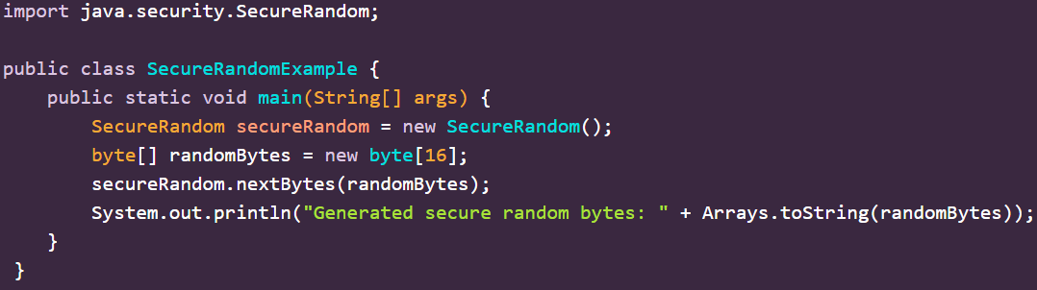

SecureRandom in action

The code above solves the following issues:

* Insufficient system entropy due to lack of unpredictable events.
* Poor configuration of the random number generator
* Operating in a virtualized environment with limited access to hardware entropy sources

Details on the solution:

* Use a hardware random number generator (HRNG) which can provide high-quality entropy.
* Configure the JVM to use an alternative source of entropy, such as a secure file or device that gathers random data.
* Increase system entropy by monitoring and managing entropy sources, particularly in virtual machines

Entropy = a measure of disorder or randomness in a system.

Always use SecureRandom instead for cryptographic applications.

To provide adequate entropy sources in cloud or virtualised environments, implement additional entropy gathering methods like using /dev/random or /dev/urandom on Linux.